PRELIMINARY COMMENTS
REGARDING
US ARMY CORPS OF ENGINEERS
JULY 31, 2020
COASTAL STORM RISK MANAGEMENT FEASIBILITY STUDY
COLLIER COUNTY, FLORIDA

KPR Capital LLC

March 17, 2021

PRELIMINARY COMMENTS
REGARDING
US ARMY CORPS OF ENGINEERS
JULY 31, 2020
COASTAL STORM RISK MANAGEMENT FEASIBILITY STUDY
COLLIER COUNTY, FLORIDA

TABLE OF CONTENTS
I. Introduction

A. Parameters of the Project
B. Cost and Time of the Project
C. The Written Report on the Project
D. Goal of the Project
E. Conclusion

II. Overview of the Project

A. Initial 5-Year Construction
1. Floodwalls
2. Steel gate enclosures
3. Berms
B. 50-Year Plus Operation and Maintenance
C. Cost of the Project: $60 Million Per Year
D. Goal of the Project

III. ACE: A Troubled History

A. Hurricane Katrina Failures
B. Public Record of ACE Deficiencies
C. Other Currently-Proposed Projects
D. Conclusion

IV. Transparency of the Written Report

A. Inconsistent with Fundamental Principles of Clarity
B. Inconsistent with Federal Law and Defense Department Program
C. Conclusion

V. ﻿Climate Change, Sea Level Rise, Storm Surges
A. Introduction
B. Questions Unanswered
C. Conclusion

VI. Naples Pier Sea Level Rise Data of One Inch Per Decade: $600 Million Per Inch

VII. ﻿Adverse Impacts of the Project

VIII. ﻿Material Issues Not Covered in the Report
A. Aesthetics
B. Property Values
C. Financing and Property Taxes
D. Tourism
E. Natural Restocking of Real Estate Structures
F. Other Factors Beyond Storm Surge Flooding on the “Surface” Terrain
﻿G. Collier County Existing Programs
﻿H. Excluded Beach Locations
I. ﻿Litigation Potential and Costs
﻿IX. ﻿Conclusion

PRELIMINARY COMMENTS
REGARDING
US ARMY CORPS OF ENGINEERS
JULY 31, 2020
COASTAL STORM RISK MANAGEMENT FEASIBILITY STUDY
COLLIER COUNTY, FLORIDA

I. Introduction

These preliminary comments are being presented in connection with the proposed project described in the “Collier County Coastal Storm Risk Management Feasibility Study” dated July 31, 2020 (the “Study” or “Project”). This Study was prepared by the US Army Corps of Engineers (“ACE”), which would also implement the Project. It is submitted that this Project should not be pursued.

A. Parameters of the Project

The Study proposes a massive undertaking that would forever alter the pristine and tranquil character of Collier County. The Project would cede control of the County’s beaches, waterways, and large areas of its communities to ACE, an agency of the federal government. This agency has a documented history of project deficiencies.
The proposal would install physical structures (such as floodwalls, berms, gates, and sluices) on the beaches, in the waterways, and throughout the County. It would have a particularly devastating impact on the City of Naples. The Project would materially and adversely affect aesthetics, property values, property taxes, and tourism. There would be forced relocation of a large number of residents, the elevation (stilting) of approximately 1,350 structures, and potential adverse impacts on the downtown Naples historic district.

B. Cost and Time of the Project

﻿The proposal is currently estimated to cost over $3 billion, $1 billion plus of which would be the responsibility of the County and its residents. It would last at least 55 years, but more likely it would last in perpetuity and create its own bureaucracy. There would be 2 phases: 5 years of initial construction followed by 50 years of the federal government “monitoring,” at least annually, the County’s “operation and maintenance.” The operation and maintenance would be the sole financial responsibility of the County. To put the enormity of this Project and its costs in perspective, $3 billion over 50 years is $60 million per year.

C. The Written Report Describing the Project

The Study is embodied in a 1600-plus page report (including 9 appendices) (the “Report”). It contains numerous charts, graphs, figures, formulas, statistical models, and over 100 acronyms. The Report frequently discusses the same topics in multiple places without cross referencing. It imbeds an environmental impact statement in the middle of the Report that adds to its complexity. The Report is not “clear, concise, and well-organized” as provided by federal law and Department of Defense guidelines.
D. Goal of the Project

﻿The Project does not purport to address the overall issue of coastal flooding risk management. As the Report acknowledges, “This project is not an all-encompassing solution that would address all of coastal storm risks in Collier County...” Rather, it only seeks to address one aspect of this complex issue: an attempted mitigation of the impact of a projected 50-year increase in storm surges caused by rising local sea levels allegedly due to climate change caused by global warming.

The bases for this entire endeavor are historical data from 1963 to 2013 collected at the Naples Pier. These data reflect a local sea level rise of 1/10th of 1 inch per year. This translates into less than 1 inch per decade over 5 decades, the time period of the Project. These data seem insufficient to justify this massive $3 billion structural intrusion into Collier County. To put this into perspective, the cost of the “mitigation” effort would be approximately $600 million per inch of projected local sea level rise over 50 years.
Further, there are no assurances that the Project will work. The Report concedes that if the Project were to work it would mitigate only some storm surge scenarios. The Report also concedes some scenarios sought to be addressed may never occur. Moreover, there will remain other significant flooding issues, atmospheric conditions (such as wind), and related factors that are beyond anyone’s ability to mitigate.

E. Conclusion

It is respectfully submitted that the County’s contribution of $1.1 billion plus toward this Project’s cost of over $3 billion would be better spent by the County itself. The County has local knowledge and expertise and ready access to resident participation. The County’s future should not be dictated by a federal agency in Washington, D.C.

Accordingly, this Study should be stopped as soon as reasonably possible, and the Project should not be pursued. The County and its residents should continue to retain control of their own destiny and should continue to manage water/flooding issues locally and not cede their future to a historically troubled agency of the federal government.

II. Overview of the Project

A. Initial 5-Year Construction

Collier County is one of this country’s and perhaps one of the world’s premier locations/destinations for seaside living and recreation. If this proposed Project were implemented, ACE would come in, with its cranes, bulldozers and other heavy equipment, for at least a period of 5 years of initial construction (commencing in 2025). The Project would include:

- 14 foot floodwalls
- 62 steel gate closures imbedded inside of the floodwalls
- 14 foot berms (blocking water views and sunsets)
- sluice gates
- surge barriers
- jetties
- pumping stations
- forced relocations of large numbers of families (using eminent domain if necessary)
- elevating (stilting) over 1300 structures, some in the historic district of downtown Naples.

1. Floodwalls

﻿The 14-foot floodwalls are to be supported by large foundational structures that would be installed underground. These supports would be to a depth and a width approximating the 14-foot height of the floodwalls themselves. They would include 20-foot deep by 1.5 foot wide concrete pilings. Attachment A reflects visual depictions of the floodwalls and the embedded steel gate closures at issue from Appendix B to the Report.

2. Steel gate enclosures

The proposed 62 or so steel gate closures, depicted in Attachment A, would range from 25 feet to 175 feet in width. Locations would include:

- 4th Avenue South
- 10th Street South
- multiple locations on Tamiami Trail
- Goodlette Frank Road
- Davis Boulevard
- Airport Pulling Road
- Crayton Road
- Bonita Beach Road
- numerous “private entrances”

Attachment B reflects a full list of the proposed 62 steel gate closures from Appendix B to the Report.

3. Berms

The 14-foot berms are proposed to be constructed along 9.5 miles of Naples’ beaches. In the 1600-page Report, there appears to be no specific description or visuals of how the 14-foot berms are to be built or what they would look like. The limited information provided is that they could be 14 feet high and extend west some 75 feet up to 150 feet, possibly into the Gulf of Mexico. There are also a number of references to “concrete features” that may be underneath and support these berms, without any further details provided.

B. 50-Year Plus Operation and Maintenance

After the initial construction is completed over 5 years (2025-2030), ACE would be here for another 50 years (2030-2079) and beyond to “monitor and inspect” the operation, maintenance, repair, replacement, and rehabilitation of the Project. ACE would perform annual inspections to ensure that the County was appropriately maintaining this massive Project. The County would be required to provide written documentation that it was complying with its maintenance obligations. This could create a bureaucracy of its own.

The County would be financially responsible (estimated cost to be $1 million per year) for this aspect of the Project at no cost to the federal government. Moreover, the County would be required to provide a hold harmless agreement to the federal government from liability arising from the Project.

C. Cost of the Project

The Study estimates that the Project will cost $3 billion plus. Based on past experience with government projects, the total cost will likely be significantly more. Indeed, in FAQs relating to the Project, the cost is “estimated at $4.8 billion.” The total length of the Project is approximately a 50 year time period. This produces an expenditure of some $60 million per year. The massive size of this Project, the enormity of its cost, and the devastating impact on the communities of Collier County that it will have, require overwhelming evidence that this Project is fully warranted by the purported threat that it seeks to address.

D. Goal of the Project

The Project does not purport to address the overall issue of coastal flooding risk management. As the Report acknowledges, “This project is not an all-encompassing solution that would address all of coastal storm risks in Collier County...” Rather, it only seeks to address one aspect of this complex issue: an attempted mitigation of the impact of a projected 50-year increase in storm surges caused by rising local sea levels allegedly due to climate change.

According to the Report, these surges may or may not occur between 1 to 1,000 years into the future. As ACE concedes, if the Project were to work, it would only partially address the water/flooding issues that have confronted and may confront the County in the future. ACE also concedes some of these issues, such as wind damage, cannot be mitigated at all.

III. ACE: A Troubled History

﻿ACE has a history of deficiencies in its design and execution of projects directed at solving or mitigating coastal flooding issues. Some have suggested that part of the problem with ACE is that in the 1980’s it began a transition from an agency of engineers to an agency of contract administrators, who hire and manage third parties to do the work. Some have also suggested that for state and local governments it may be more prudent to do projects themselves rather than fall prey to the allure of federal funds.

A. Hurricane Katrina Failures
﻿
The failure that has received the most notoriety is New Orleans and Hurricane Katrina. In the aftermath of the storm, there was litigation brought against ACE. As the United States District Court Judge (Stanwood R. Duval Jr.) found:

﻿“The Corps’ lassitude and failure to fulfill its duties resulted in a catastrophic loss of human life and property in unprecedented proportions. The Corps’ negligence resulted in the wasting of millions of dollars in flood-protection measures and billions of dollars in Congressional outlays to help this region recover from such a catastrophe.”

In re Katrina Canal Breaches Consolidated Litigation, 647 F.Supp.2d 644, 711 (E.D. La. 2009).

In a prior opinion, Judge Duval also observed:

- “While the United States government is immune for legal liability for the defalcations alleged herein, it is not free, nor should it be, from posterity’s judgment concerning its failure to accomplish what was its task.”
- “This story — fifty years in the making — is heart-wrenching. Millions of dollars were squandered in building a levee system with respect to these outfall canals which was known to be inadequate by the Corps' own calculations.”
- “The cruel irony here is that the Corps cast a blind eye [...] solely focused on flooding caused by storm surge.”
- “Such egregious myopia is a caricature of bureaucratic inefficiency.”

In Re Katrina Canal Breaches Consolidated Litigation, 533 F. Supp. 2d 615, 643, (E.D. La. 2008).

On appeal, the Fifth Circuit Court of Appeals left the foregoing findings undisturbed.

B. Public Record of ACE Deficiencies

﻿Over the years, numerous publications have discussed ACE’s shortcomings. These publications are consistent with the findings of the federal judge quoted above. It appears that this Project may be similarly flawed.

C. Other Currently-Proposed Projects

The Collier County Project appears to be a part of a larger national program. For example, ACE has devised a project in Miami-Dade, entitled: “Miami-Dade Back Bay Coastal Storm Risk Management Feasibility Study” (August 4, 2020). It is very similar to the Study for Collier County: walls, berms, sluices, etc. The Miami-Dade project is currently receiving intense criticism. For example, Cummins | Cederberg, a coastal and marine engineering firm, released a review cataloguing numerous deficiencies with the Miami-Dade study. Many of these deficiencies are similarly applicable to the Study for Collier County at issue here.

Another ACE study and plan is for the New York and New Jersey area in the aftermath of the storm Sandy. The funding for this study has recently been frozen. The New York project proposed in part to create a 5-plus mile barrier extending from Sandy Hook, New Jersey, to Breezy Point on Long Island, to protect New York harbor from storm surges. New York harbor has survived for centuries without such a barrier. At least one highly-placed federal official has called the New York project “foolish.”

D. Conclusion

It is submitted that the County has and can continue to intelligently manage its water/flooding issues locally. The County has local knowledge developed over decades relating to the environmental, aesthetic, ecological, and economic aspects of Collier County. These matters are complex involving a myriad of issues and disciplines going beyond water, flooding, and whatever expertise ACE may have to offer. That expertise clearly does not include, among other things, the aesthetics of our living environment, the local economy, property values, property taxes, and tourism.

IV. Transparency of the Written Report

A. Inconsistent with Fundamental Principles of Clarity

﻿The Study purports to elicit input from “stakeholders.” According to the Report, stakeholders include the residents of Collier County and the general public. Yet, the Report that embodies the Study is so long, complex, and confusing that it cannot be easily understood by almost anyone, and especially not the average resident or the general public.

The Report, including its 9 appendices, is over 1600 pages single-spaced. There is a 28-page Table of Contents and a 6-page, single-spaced “Executive Summary” that one could say at best is densely written. There are over 100 of acronyms and hundreds of figures, graphs, and tables. The Report ends with 9 pages of Conclusions and Recommendations. The 9 appendices are voluminous in their own right. ﻿For example, Appendix B including sub-appendices is over 600 pages alone. It is difficult to consider the Report a genuine attempt at “transparency.”
B. Inconsistent with Federal Law and Defense Department Program

Moreover, the Report appears to violate the “plain language” provisions of federal law and the Department of Defense Program implementing that law. In 2010 Congress enacted a federal statute entitled “the Plain Writing Act of 2010.”

Pursuant to this federal statute, the Department of Defense (under which ACE operates) has adopted the “DoD Plain Language Program” (DoD Instruction 5025.13), the most recent version of which is dated January 23, 2020. This Program provides documents like the Report be expressed in “clear, concise, and well-organized language” in order to “effectively communicate with intended audiences.” This Defense Department Program has extensive training materials and guidelines in order to achieve the goals of clarity, conciseness, and organization. The Report seems to violate virtually every one of these standards.

C. Conclusion

In sum, the Report supporting this Project is far from a paradigm of transparency. It should not be this difficult to explain to the residents of Collier county why they should support this multi-billion dollar Project.

V. ﻿Climate Change, Sea Level Rise, Storm Surges

A. Introduction
The fundamental premises of this $3 billion plus Project are (a) that storm surges are projected to increase in size in Collier County (b) due to a projected rise in local sea levels (c) which is in turn due to global warming. The time period the Report focuses on is 2030-2079, the 50 years of mitigation after the completion of the initial 5 year (2025-2030) construction Project. These premises raise at least three fundamental issues:

- what is the projected rise in sea levels in Collier County for this time period?
- what is the projected increase in storm surge size as a result of the projected local sea level rise?
- how effective will the Project be at mitigating these surges?

B. Questions Unanswered

It is impossible to find simple, clear, coherent, and concise answers to these fundamental questions in the 1600-page Report. For example, there are no such answers in the Executive Summary nor in the Conclusions and Recommendations, where you would expect to find them.

﻿In the Report, there are over 260 references to climate change, over 290 to sea level rise, and over 250 to storm surges. These discussions are laden with figures, graphs, tables, over 100 acronyms, technical jargon, and statistical models that defy comprehension. For example, something called the “Sea Level Change Curve Calculator” is at various points used to “enhance” the historical data to reach certain results. These statistical calculations frequently end up with different results and are based on different data sets for different periods of time. The discussions are scattered throughout the Report, often without cross-references, and are on many occasions repetitious but stated in different words.

C. Conclusion

The parameters, which are sought to be analyzed in the 1600-page Report, are highly variable and difficult to predict with any genuine degree of certainty. Yet, the Study struggles to impose certainty on what is inherently speculative. The Study relies on what at-best could be described as inscrutable, obscure, and at times incomprehensible statistical modeling that amalgamate disparate collections of data and impose assumptions upon assumptions. It is submitted that this sort of analysis does not justify the expenditure of billions of dollars.

VI. Naples Pier Sea Level Rise Data of One Inch Per Decade: $600 Million Per Inch

Most of the Report’s discussions and statistical calculations related to local sea level rise are based on historical data specific to Collier County collected from 1965 to 2013. These data, cited numerous times throughout the Report, were collected at the Naples pier by the National Oceanic and Atmospheric Administration (“NOAA”).

ACE uses the historical Naples pier data “from 1965 to 2013” to project a future local sea level rise increase of “0.79 feet in 100 years.” The Report does not convert the data to inches. When converted to inches, “0.79 feet” reflects:

- an increase of 9 inches in 100 years
- 9 inches converts to 4.5 inches over 50 years (the focus of the Study)
- 4.5 inches converts to less than 1 inch per decade
- which in turn converts to 1/10th of an inch per year
The NOAA data of a local sea level rise of 1/10th of 1 inch per year appears to be the most relevant data upon which ACE relies to support this Project. Indeed, the Naples Daily News has reported on this Study and focuses on these same data (2 Oct 2020). Given this relatively minimal sea level rise and the numerous other variables at work, such as atmospheric, environmental, and local factors, it may be more prudent for the County to closely monitor the local sea level data going forward, rather than launch this massive multi-billion-dollar Project.

Moreover, as noted above, the goal of this Project is not to address overall costal storm risk in Collier County. Rather, the goal is “mitigation” not prevention nor elimination of the threat of storm surges due to increased local sea levels. Based on the Naples pier data above, the cost of this mitigation effort would be $600 million per inch of local sea level rise over 50 years.

Of course, forecasting future weather and atmospheric conditions has been notoriously challenging, and no one knows what the future may bring. However, the expenditure of billions of dollars on this Project, which would decimate our pristine and tranquil community and cede control of Collier County’s beaches and waterways to the federal government, needs to be based on information that is more significant, certain, and substantial than currently presented in this Study.

VII. ﻿Adverse Impacts of the Project

As is evident from the foregoing, this will be quite a disruptive construction process, focused on the beaches and waterways of our pristine and tranquil community, lasting at least 5 years for initial construction. These adverse affects would continue in perpetuity. Even the Report recognizes the myriad of potential adverse consequences to our living environment. The Report in the Executive Summary (at pages iii to vi) describes certain adverse impacts of the Project as follows:

- “There will be direct and indirect, temporary and permanent adverse effects on land use and socioeconomics that are moderate to significant.”
- “There would be minor, temporary and permanent adverse effects on land use, navigation, recreation, and aesthetics ....”
- “[T]here would also be temporary, minor to moderate adverse effects on transportation, navigation, and safety, after construction, during gate closures.”
- “Roadway Gates would be incorporated throughout the floodwalls to allow transportation access through the floodwalls.”
- “Storm surge Gates and/or tide Gates would be installed along navigable channels ....”
- “There would be moderate potential for permanent adverse effects...primarily in the...Naples Historic District ....”
- “Impacts to threatened and endangered species and marine mammals would range from adverse to beneficial impacts that are temporary to permanent and range from negligible to moderate impacts.”
- potential adverse impacts/effects on mangrove wetlands, submerged aquatic vegetation, beach dune vegetation
- potential adverse impact on “water quality,” “fauna,” “fish habitat,“ “fisheries,” “coral”

In short, the Study itself acknowledges the potential significant detrimental impact of the Project on Collier County. This Project is simply not justified when the County and its residents can take its $1.1 billion plus portion and put it to good use mitigating the water/flooding issues as the County and its residents see fit. The County can use its historical knowledge and prudent best judgment that is responsive to residents, rather than turning it over to a troubled federal agency that is a stranger to our community.﻿

VIII. ﻿Material Issues Not Covered in the Report
The Report does not address adequately a number of highly relevant and material issues. ﻿These issues would have a significant impact on Collier County and its residents. They include: aesthetics, property values, property taxes, and tourism. ﻿
A. Aesthetics
The Report acknowledges that Collier County is an idyllic, pristine, serene paradise with it beaches and waterways. It attracts people from around the world to purchase property here and to visit as tourists.
A major component of this attraction is the County’s aesthetics: its flora and fauna, greenery, trees, water views, sandy beaches, and priceless sunsets. The Report at page 111 actually attempts to define “aesthetics”: “the study of sensory emotional values.” It goes on to observe that “as a result” aesthetics “is subjective by nature.” It notes next that “There are no State or Federal regulations for aesthetics.”

The adverse impact on the County’s living environment and aesthetics is an essential issue to be examined by the County and its residents. The Study fails to address this critical issue.
B. Property Values

The Report does not deal with the effect on property values of the Project, with its 14-foot walls and berms and closure gates, and the 5-year period for construction followed by 50 years plus of operation and maintenance. People retire to and visit Collier County for the aesthetics and peace and serenity in their later years as the reward for many decades of work. The Project does not seem consistent with these objectives. While the Report does not deal with property values, the FAQs do and state as set forth below that any impact cannot be predicted:

“Will property values go down/up if I live in unprotected/protected areas? We cannot predict the project’s impact on future property values. Property values may be affected by project implementation, but there are too many factors to make a determination during this study.”

C. Financing and Property Taxes
The Report does not address the critical issue of the financing for this Project and the potential for increased property taxes resulting from the significant cost of the Project. As one Collier County official is quoted as saying, once we have the “right plan,” “then smarter people than me will work on the financing...” (Naples Daily News, 2 Oct 2020). This is obviously not an acceptable answer.

D. Tourism
The impact of the Project on tourism, what is believed to be the economic lifeblood of the area, is critical to the evaluation of the Project. Tourists come here for many of the same reasons noted above that they relocate and retire here.

﻿The Report (Appendix C at pages 107-110) does contain a purported discussion of the economic impact of the Project on tourism with statistical formulas and calculations based on highly selective data. It is submitted that this discussion does more to confuse than enlighten on this significant issue.
E. Natural Restocking of Real Estate Structures

﻿Another important factor not given any serious consideration in the Report is the replacement of older housing stock and other physical structures by newer ones.

One of the driving forces underlying the Project is mitigation of damage to property. The Report notes that 95% or so of coastal property in Collier County is built out, and therefore there is very little truly new building on the coast. Rather, old structures are constantly being replaced by newer structures that are much more storm-resistant as they must comply with newer construction codes. This replacement occurs for a number of reasons. One is people moving to Florida and renovating. Another is owners refurbishing. Another may be storm-related, much of which may be covered by insurance. Additionally, developers invest in “tear-downs” and create new housing stock.

Without any analysis, the Report at page 46 bundles in one sentence this restocking phenomenon with climate change and funding limitations and dismisses it as part of a process that is “difficult and slow.” This is not an adequate analysis of this important issue.

﻿F. Other Factors Beyond Storm Surge Flooding on the “Surface” Terrain
The consequences arising from coastal flooding raises a myriad of complex issues. The principal consequences include property damage and bodily injury. The Report fails to address a number of factors that affect these consequences. For example, storms are accompanied by intense and highly variable wind activity. Wind by itself can cause severe property damage and bodily injury.

In addition, storms can cause severe underground water activity caused in part by rainfall but also by underground hydrodynamic factors, such as a high underground water table. Again, this underground water activity on its own can cause significant damage to person and property.

Spending billions of dollars to mitigate storm flooding on the surface of the terrain would be totally ineffective to mitigate the consequences of wind and underground water activity. The Report fails to address adequately material issues such as these that go beyond simple surface water activity.

﻿G. Collier County Existing Programs
Collier County has existing programs to address coastal flooding. Yet, the Report does not clearly and adequately describe those programs and address why the Project is better. For example, a driving force behind the Study and the Project is the economic loss/damage to physical structures such as residential, commercial, and governmental properties resulting from storm surges. A critical aspect of this type of loss/damage is the insurance coverage currently in place to mitigate these losses. Yet, the Report gives no consideration to this important issue other than general references to FEMA.
H. Excluded Beach Locations

The Report fails to address why Port Royal just above Gordon’s Pass is not included in the Project and not subjected to 14 foot walls and berms. Port Royal is estimated to include some of the most expensive residential real estate in the United States and in the world. Many of the properties sit right on the Gulf of Mexico. If 14 foot floodwalls and 14 foot berms were proposed for Port Royal properties, it would be expected that its residents would not tolerate such a proposal because it could erode their ambiance and their economic value. Similarly, the Report does not adequately address why the two hotels (Ritz Carlton and Naples Grande) and abutting areas were not subjected to the same floodwall/berm regimen as other locations covered in the Project.

I. ﻿Litigation Potential and Costs
As noted above, ACE has been involved in a number of lawsuits alleging deficiencies in the design and execution of its projects. The local sponsor, in this case Collier County, is frequently also sued. Pursuant to the agreement implementing the Project, the County would be required to undertake to hold the federal government harmless except for its own or its contractors’ fault or negligence. Given ACE’s litigation history, it would be informative if ACE had analyzed its and the County’s possible legal liabilities and litigation costs arising from the Project and what the parties could do to mitigate that legal exposure.

As demonstrated above, there are a significant number of critical issues regarding the impact of this Project on the communities comprising Collier County. These issues are yet to be considered and addressed in any meaningful fashion. If appropriately considered and addressed, these issues would dictate that this Project not be implemented.

﻿IX. ﻿Conclusion
In sum, it is respectfully submitted that this Study should be discontinued as soon as reasonably possible, and the Project should not be implemented.

- This proposed 55-year plus, $3 billion plus Project would have a profound adverse impact on our pristine and tranquil community in perpetuity.
- The Project would transfer control over the County’s beaches and waterways from the residents of Collier County to a federal agency with a history of project deficiencies. The County’s future should not be dictated by a historically troubled agency of the federal government located in Washington, D.C.
- The Project would adversely affect the County’s communities and their ecology, aesthetics, economy, property values, property taxes, and tourism.
- The County’s contribution of $1.1 billion plus would be better spent by the County itself, with the County’s local knowledge, expertise, and resident participation.
- The Project is supported by a 1600-page plus Report. The Report appears to violate the “plain language” directives of federal law and the common sense notions of transparency.
- The Project involves the expenditure of large amounts of money and presents the allure of billions of dollars of federal money in exchange for ceding control of the County’s most valued assets. The cost of the Project would, at a minimum, be $60 million per year over 50 years.
- The Project is based on a purported threat of an assumed rise in local sea levels of 1/10 of 1 inch per year. It would cost $600 million per inch of assumed sea level rise that may not occur.
- The Project attempts to solve a problem that may not be solvable, may not exist, and may be addressed much more efficiently and economically at the local level.
The County and its residents should continue to retain control of their own destiny and should continue to manage water/flooding issues locally and not cede their future to a troubled agency of the federal government.

KPR Capital LLC

March 17, 2021

PRELIMINARY COMMENTS
REGARDING
US ARMY CORPS OF ENGINEERS
JULY 31, 2020
COASTAL STORM RISK MANAGEMENT FEASIBILITY STUDY
COLLIER COUNTY, FLORIDA

ATTACHMENT A: T-Wall Figures

“Figure 5.31 Graphical drawing of a typical T-wall cross-section (Image courtesy of Tulane University)”

“Figure 5.32 Existing T-wall located at the Richmond, VA Flood Control Project”

“Figure 5.33 Bird’s eye view of a gate closure apart of the existing Norfolk Floodwall.”

“Figure 5.34 A gate closure apart of the existing Norfolk Floodwall.”

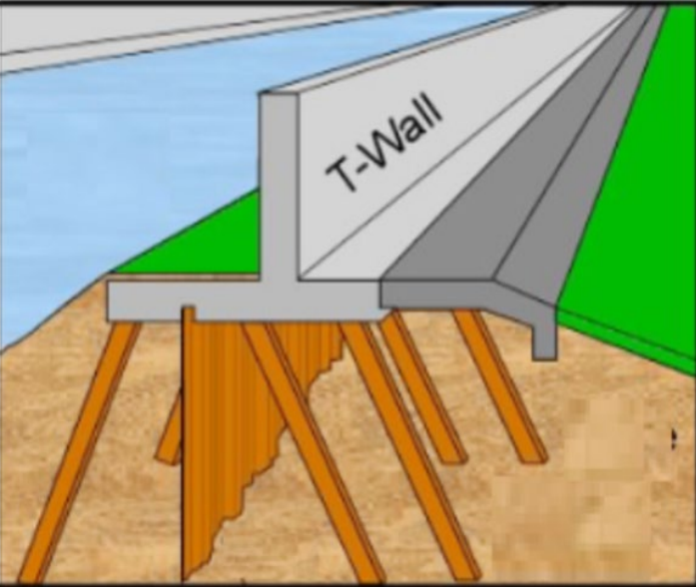
“Figure 5.31 Graphical drawing of a typical T-wall cross-section (Image courtesy of Tulane University)”
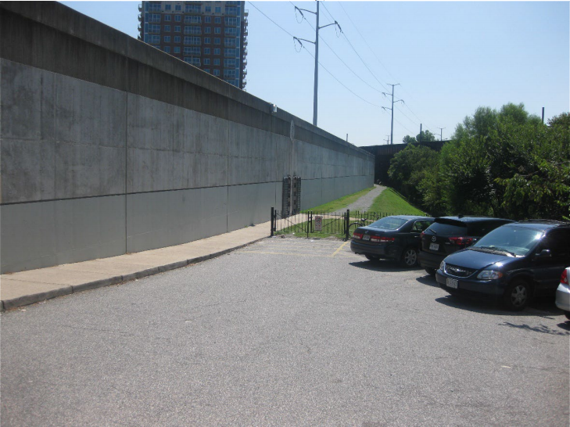
“Figure 5.32 Existing T-wall located at the Richmond, VA Flood Control Project”
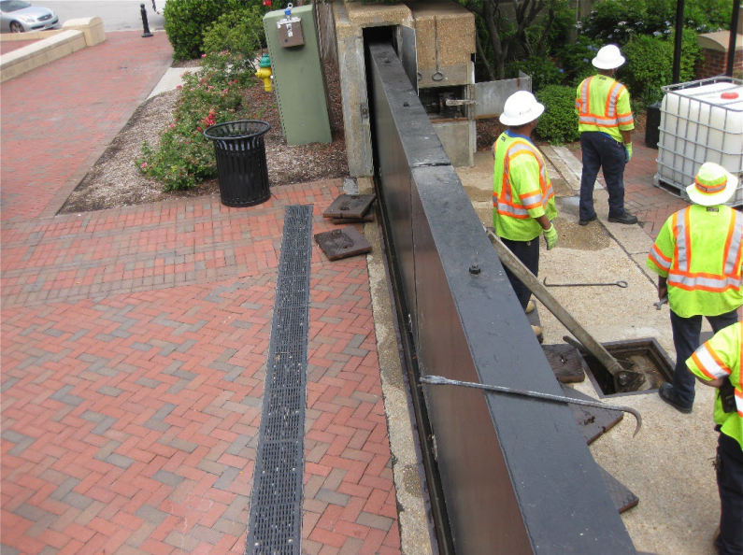
“Figure 5.33 Bird’s eye view of a gate closure apart of the existing Norfolk Floodwall.”
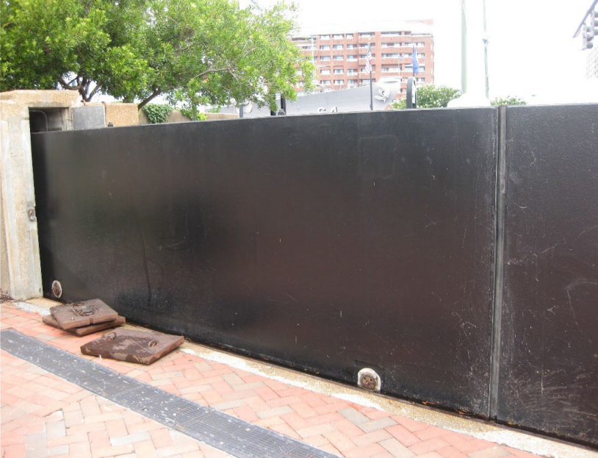
“Figure 5.34 A gate closure apart of the existing Norfolk Floodwall.”

PRELIMINARY COMMENTS
REGARDING
US ARMY CORPS OF ENGINEERS
JULY 31, 2020
COASTAL STORM RISK MANAGEMENT FEASIBILITY STUDY
COLLIER COUNTY, FLORIDA

ATTACHMENT B: Gate closure Locations

“Table 5.17 Bonita Beach Road Alignment Proposed Gate Closures (T.O.W. 14 FT NAVD88)”

“Table 5.18 Seagate Drive Alignment Proposed Gate Closures (T.O.W. 14 FT NAVD88)”

“Table 5.19 Tamiami Trail Alignment Proposed Gate Closures (T.O.W. 14 FT NAVD88)”

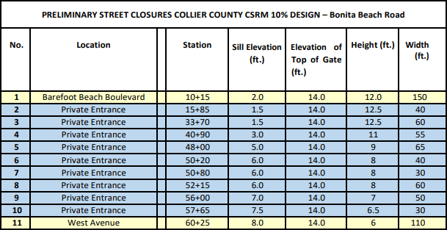
“Table 5.17 Bonita Beach Road Alignment Proposed Gate Closures (T.O.W. 14 FT NAVD88)”
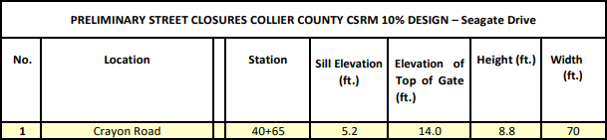
“Table 5.18 Seagate Drive Alignment Proposed Gate Closures (T.O.W. 14 FT NAVD88)”
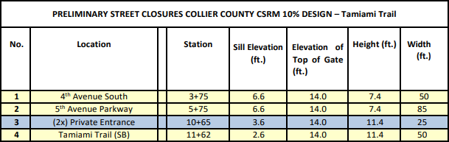
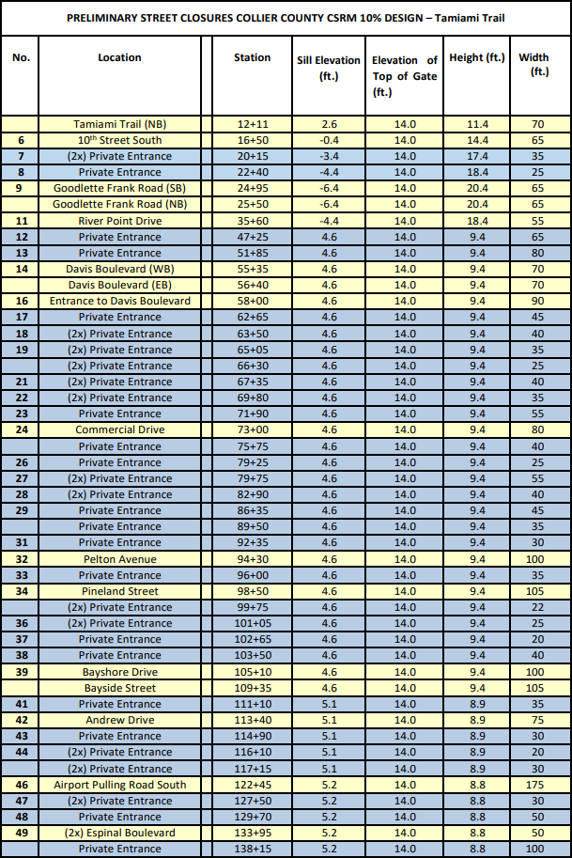
“Table 5.19 Tamiami Trail Alignment Proposed Gate Closures (T.O.W. 14 FT NAVD88)”

